Packet Tracer – Configuring Dynamic NAT

1. Topology

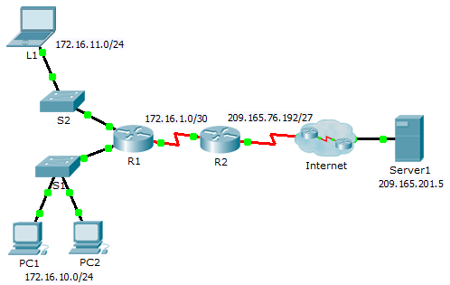

1. Objectives

Part 1: Configure Dynamic NAT

Part 2: Verify NAT Implementation

1. Configure Dynamic NAT
   1. Configure traffic that will be permitted.

On **R2**, configure one statement for ACL 1 to permit any address belonging to 172.16.0.0/16.

**access-list 1 permit 172.16.0.0 0.0.255.255**

* 1. Configure a pool of address for NAT.

Configure **R2** with a NAT pool that uses all four addresses in the 209.165.76.196/30 address space.

**ip nat pool any-name-here 209.165.76.196 209.165.76.199 netmask 255.255.255.252**

Notice in the topology there are 3 network ranges that would be translated based on the ACL created. What will happen if more than 2 devices attempt to access the Internet?

**Perangkat tambahan akan ditolak aksesnyasampai salah satu terjemahan sebelumnya habis untuk menggunakan alamat yang akan digunakan.**

* 1. Associate ACL1 with the NAT pool.

**ip nat inside source list 1 pool any-name-here**

* 1. Configure the NAT interfaces.

Configure **R2** interfaces with the appropriate inside and outside NAT commands.

**interface s0/0/0**

**ip nat outside**

**interface s0/0/1**

**ip nat inside**

1. Verify NAT Implementation
   1. Access services across the Internet.

From the web browser of **L1**, **PC1**, or **PC2**, access the web page for **Server1**.

* 1. View NAT translations.

View the NAT translations on **R2**.

R2# **show ip nat translations**